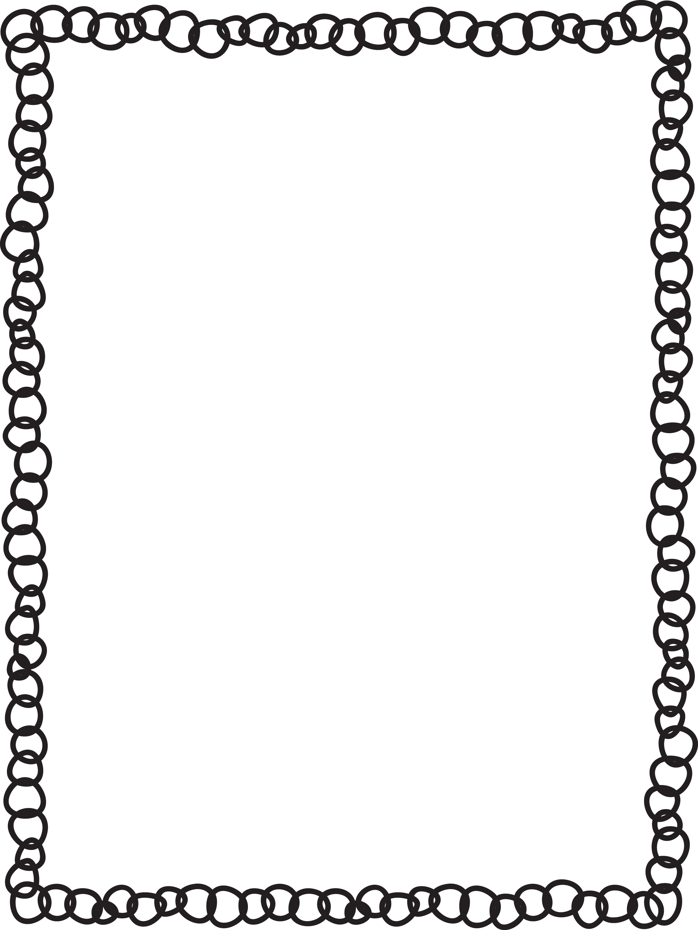

Scientist:_________________________ Date:__________

Oil Lava Lamp

**QUESTION**

Can I create a gas using only a solid and a liquid?

**HYPOTHESIS**

I think that ______________________________ ________________________will happen because _______________________________________.

**MATERIALS**

Clean, plastic soda bottle, glass, jar, or Baby Soda Bottle

Vegetable oil (the cheaper the better)

Food coloring

Alka-Seltzer tablet or Fizzy Tablets

Funnel

Water

**EXPERIMENT**

1. Put on your safety goggles!
2. Fill the bottle 3/4 full with vegetable oil.
3. Fill the rest of the bottle with water (almost to the top but not overflowing).
4. Add about 10 drops of food coloring. Be sure to make the water fairly dark in color. Notice that the food coloring only colors the water and not the oil. Hmmm…
5. Divide the Alka-Seltzer tablet into 8 pieces.Drop one of the tiny pieces of Alka-Seltzer into the oil and water mixture. Watch what happens. When the bubbling stops, add another chunk of Alka-Seltzer. It’s just like a lava lamp!

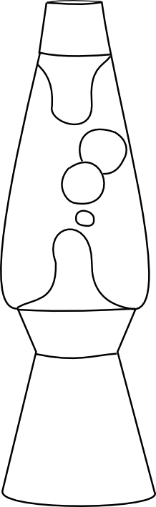



Oil Lava Lamp

RESULTS

Draw a detailed scientific sketch of what you observed

**OBSERVATION**

Write a vivid statement on what you observed using your senses.

**CONCLUSION**

I agree / disagree with my hypothesis because _______ _______________________________________________________________________________________

CONCLUSION

I agree / disagree with my hypothesis because _______ _______________________________________________________________________________________

|  |  |
| --- | --- |
| Sight |  |