Name: _____________________________________ Date: ____________________

Operation Oil Spill Cleanup
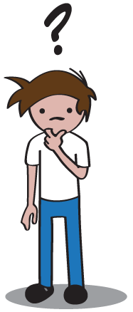
Question
How do scientists clean up the environment after pollution has occurred?

Research
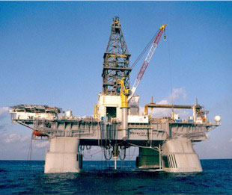
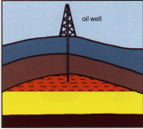
Oil is an important natural resource for our country. Out in the ocean, an oil rig is
set up to drill deep into the ground. Oil is sucked out of the earth into pipes and then moves through pipes to the shore.

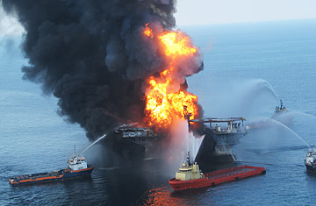
Drilling for oil raises the risk of oil spills in the water. Oil spills can damage fishing areas, spoil beaches, kill animals, and destroy the ocean. Only 3.8 gallons of oil can ruin as many as 20 million gallons of water! In 2010, an oil rig called the Deepwater Horizon exploded and caught fire. A large amount of oil started leaking into the ocean. How do you think this affected the environment? What do you think scientists did to clean up the pollution in the water?

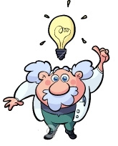
Hypothesis
(Make your best guess at the answer to the question at the top of the page.)

In order to clean up after pollution has occurred, I think scientists should ____________
________________________________________________________________________
________________________________________________________________________

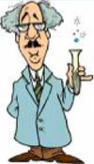
Experiment

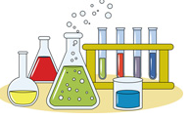
Materials
- Ocean Model: 2 large aluminum pans, sand, gravel, water, feathers, pipe cleaners
- Dropper of “Oil Spill”
- Clean up materials: spoons, aquarium nets, straws, cotton balls, sponges, paper towels, coffee filters, wood shavings, dropper bottle of soap, baking soda, flour, vinegar, spray bottle of clean water

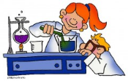
Procedure
Make an Ocean Model
- Send 2 team members to the materials station to follow these steps.
- Spread a small amount of sand on the bottom of your pan.
- On one side of the pan, make a pile of gravel.
- On the gravel, add a couple feathers (birds) and pipe cleaners (mammals)
- Pour a SMALL amount of water over the sand. DO NOT cover the rocks or animals!!

Cause an Oil Spill
- Send ONE team member to the materials station to get the oil spill bottle.
- Take the oil bottle on your table drop the oil into your pan. Make sure your oil spill pollutes the water, land, birds (feathers), and mammals (pipe cleaners).

Make a Plan for Clean Up
- Look at the materials list in your lab packet for a list of things at the “clean up station”. Decide what materials you think can help clean up the oil spill you just created.
- List two things you will try to clean each part of your station.
How will you clean the water? 1) ____________________ 2) ___________________
How will you clean the land? 1) ____________________ 2) ___________________
How will you clean the animals? 1) ____________________ 2) ___________________

- Send your “supplier” to the clean-up station to get materials you listed.

Clean up your Spill!
Try to use the materials you listed to clean up your oil spill. Make sure you record your observations on the next page!
Observations

 | Clean-Up Material | Result  (What happened when you used this material to clean up the oil?)
Water Clean Up
Land Clean Up
Animal Clean Up

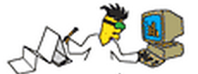
Analysis
(Answer the following questions about your experiment.)

1. What were the best materials you found for cleaning up oil:
In the water: _______________________________
On land: _______________________________
On animals: _______________________________

2. Choose ONE of the materials you wrote above. How do you think scientists could use something like this to clean up an oil spill in the real world (in a huge ocean instead of a small pan)? __________________________________________________________

________________________________________________________________________
________________________________________________________________________

3. Choose ONE of the materials you wrote above. What would be the danger of using this material in the real world to clean up an oil spill?

________________________________________________________________________
________________________________________________________________________
________________________________________________________________________

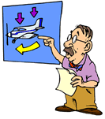
Conclusion
(Using what you have learned, go back and answer our original question.)

In order to clean up after pollution has occurred, scientists should __________________
________________________________________________________________________
________________________________________________________________________

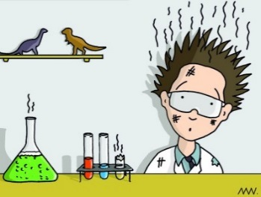
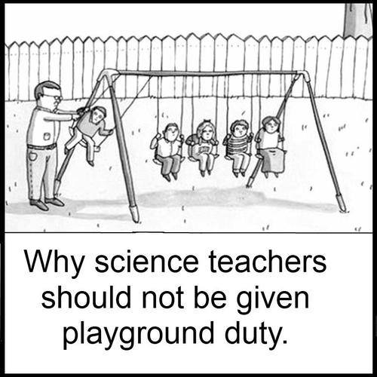

Operation Oil Spill Cleanup - Lab Prep

Georgia Performance Standards – Science
Content
S3L2. Students will recognize the effects of pollution and humans on the environment.
a. Explain the effects of pollution (such as littering) to the habitats of plants and animals.
b. Identify ways to protect the environment.

Scientific Process
S3CS1. Students will be aware of the importance of curiosity, honesty, openness, and skepticism in science and will exhibit these traits in their own efforts to understand how the world works.
a. Keep records of investigations and observations and do not alter the records later.
b. Offer reasons for findings and consider reasons suggested by others.
c. Take responsibility for understanding the importance of being safety conscious.
S3CS4. Students will use ideas of system, model, change, and scale in exploring scientific and technological matters.
a. Observe and describe how parts influence one another in things with many parts.
b. Use geometric figures, number sequences, graphs, diagrams, sketches, number lines, maps, and stories to represent corresponding features of objects, events, and processes in the real world.
c. Identify ways in which the representations do not match their original counterparts.
S3CS8. Students will understand important features of the process of scientific inquiry.
a. Scientific investigations may take many different forms, including observing what things are like or what is happening

Materials Set-Up
“Clean up materials” Station
Using the materials list on the student lab sheet, set up one central table with all of the “clean up materials”. ONE Student from each group will visit this table to get supplies throughout the course of the lab.

Student Stations
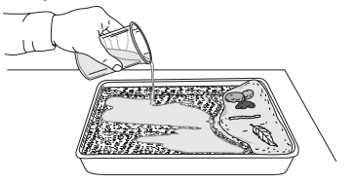
All student stations will need:
- 2 empty pie pans, one for retrieving supplies and one for testing materials
- “Ocean Shore” cake pan (see image )
  - Supplies: water, sand, gravel, feather (bird model), pipe cleaner (mammal model)
- Dropper bottle of oil (instead of pouring from a beaker as seen in the image, students will drop oil into the pan themselves from the oil bottle at the beginning of the experiment.
  - Mixture of vegetable oil with a few drops of food coloring
- Pencils
- Student lab sheets

Operation Oil Spill Cleanup - Lab Prep

Teaching Notes
Classroom Management
At the beginning of the lab, one student will need to be assigned as the “supplier”. This will be the only student that should leave the lab station in order to get more “clean up materials”.

Common Misconceptions
The hardest thing for the kids to understand in this lab is how their experiment transfers to the real world. For example, if the children clean up some of the oil with a cotton ball, they will not be able to understand a “real-world” material that is similar that can be used on a larger scale. To help children bridge this gap, you may want to talk to them about the properties of their material (composition, material, texture, etc.) and then ask them to think something that can be used on a large scale with similar properties.

Questioning Students:
One of the most important aspects of the scientific method and building 21st century skills (critical thinking, collaboration, communication, creativity) is to let the children experiment and test their own theories. While you are helping the class, consider this: Instead of showing or telling kids about the best idea, ask them questions. Starting conversations with “Why did you…” or “How did you…” will get the kids to come up with creative ideas you may have never thought of!

Some sample questions you could use:
Why is the material you picked working better than other materials you tried?
What would be some of the dangers of using the material you have picked?

