Name: _____________________________________ Date: ____________________

Get the Dirt Out!
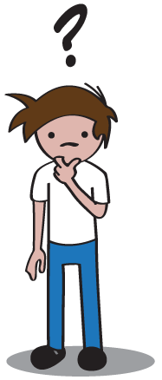
Question
How do humans make water from the environment safe to use in their everyday life?

Research
All living things require clean water to survive. Sometimes, water is polluted unsafe to drink because of the environment and human activities. Polluted or dirty water affects the lives of plants and animals and can make
them unhealthy. In some cases, polluted water can kill plants or animals. The best solution to water pollution is to prevent it from happening. This is not always possible, so scientists have come up with ways to remove pollutants from the water.
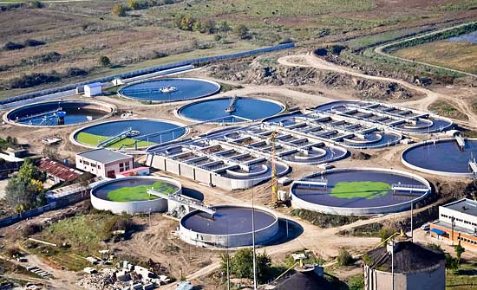
To clean the water, a city uses a water treatment plant. The plants make the water safe for the public to drink and use in their everyday life. Some things the water treatment plant has to do is get rid of dirt and small organisms. There may also be chemicals in the water that need to be removed before it is safe for people.

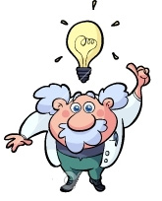
Hypothesis
(Make your best guess at the answer to the question at the top of the page.)

Humans make water safe for their everyday life by ______________________________
________________________________________________________________________
________________________________________________________________________

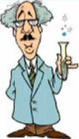
Experiment

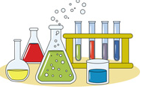
Materials
- 2 Liter Soda Bottle
- Dirty Water
- Possible Water Filters (Sand, soil, paper towels, coffee filter, gravel, cotton balls)

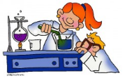
Procedure
- Put the top half of the soda bottle upside-down (like a funnel) inside the bottom half. The top half will be where you build your water filter. The bottom half will hold your filtered water.

- Fill the top half of your bottle with water filter materials. Don’t let your materials go above the line! Pick a combination of materials you think will do the best job with cleaning your water.

- Pour the dirty water into your water filter. What does the water look like?

- Test the filtered water with the water testing tool. How many dissolved solids are in the water (parts per million)?

- Dump the filter materials onto the cookie pan. Do you see any pollutants in the pan?

- Fill in the chart below with your observations.

- Repeat! Try 3 different combinations.

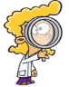
Observations
Filter Materials  (Make a list of what you tried.) | What does the filtered water look like? | How many dissolved solids are in the water? (Use water testing tool) | What pollutants got stuck in the filter materials? (What do you see in the pan?)
 |  | _____ parts per million
 |  | _____ parts per million
 |  | _____ parts per million

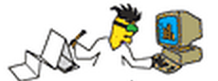
Analysis
(Answer the following question about your experiment.)

What combination of materials cleaned your water the best? What evidence do you have that proves this is the best combination?

________________________________________________________________________
________________________________________________________________________
________________________________________________________________________

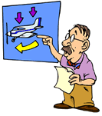
Conclusion
(Using what you have learned, go back and answer our original question.)

Humans make water safe for their everyday life by ______________________________
________________________________________________________________________
________________________________________________________________________

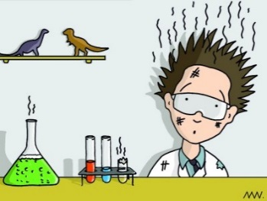
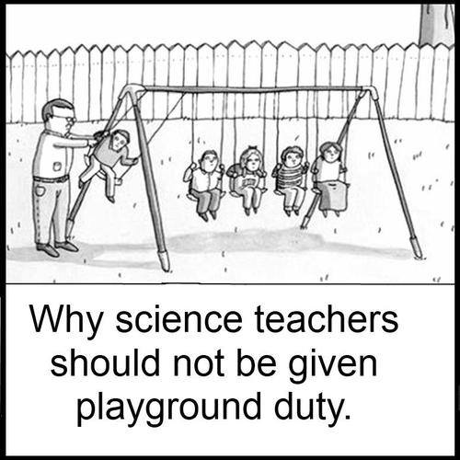

Get the Dirt Out - Lab Prep

Georgia Performance Standards – Science
Content
S3L2. Students will recognize the effects of pollution and humans on the environment.
a. Explain the effects of pollution (such as littering) to the habitats of plants and animals.
b. Identify ways to protect the environment.

Scientific Process
S3CS1. Students will be aware of the importance of curiosity, honesty, openness, and skepticism in science and will exhibit these traits in their own efforts to understand how the world works.
a. Keep records of investigations and observations and do not alter the records later.
b. Offer reasons for findings and consider reasons suggested by others.
S3CS3. Students will use tools and instruments for observing, measuring, and manipulating objects in scientific activities utilizing safe laboratory procedures.
a. Choose appropriate common materials for making simple mechanical constructions and repairing things.
S3CS4. Students will use ideas of system, model, change, and scale in exploring scientific and technological matters.
a. Observe and describe how parts influence one another in things with many parts.
S3CS5. Students will communicate scientific ideas and activities clearly.
c. Use numerical data in describing and comparing objects and events.
S3CS8. Students will understand important features of the process of scientific inquiry.
a. Scientific investigations may take many different forms, including observing what things are like or what is happening

Materials Set-Up
“Clean up materials” Station
Using the materials list on the student lab sheet, set up one central table with all of the “filter materials”.
ONE Student from each group will visit this table to get supplies throughout the course of the lab.

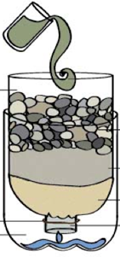
Student Stations
All student stations will need:
- Three CUT (empty) 2-Liter soda bottles (see image on right )
- Bottle of “dirty water”
  - Fill bottle with water, dirt, paper bits, and styrofoam
- Pencils
- Student lab sheets
- Water testing instrument
- Three small cookie (or pie, cake, etc.) pans

Get the Dirt Out - Lab Prep

Teaching Notes
Classroom Management
At the beginning of the lab, one student will need to be assigned as the “supplier”. This will be the only student that should leave the lab station in order to get more “clean up materials”.

Common Misconceptions
Students will not understand what “dissolved solids” are and they will not understand the measurement term “parts per million”. An adult will need to discuss this with each group as they get to the step where they measure the dissolved solids in their filtered water.

When completing the lab analysis, students will likely need support understanding what evidence is. Redirect students to their observations chart. They can use details from the chart as evidence.

Questioning Students:
One of the most important aspects of the scientific method and building 21st century skills (critical thinking, collaboration, communication, creativity) is to let the children experiment and test their own theories. While you are helping the class, consider this: Instead of showing or telling kids about the best idea, ask them questions. Starting conversations with “Why did you…” or “How did you…” will get the kids to come up with creative ideas you may have never thought of!

Some sample questions you could use:
Why is the material you picked working better than other materials you tried?
What properties do you think clean water has?
Would it be easy for a water treatment plant to use your idea with a lot of water? Why or why not.

