Name: _____________________________________ Date: ____________________

Pollution in the Water
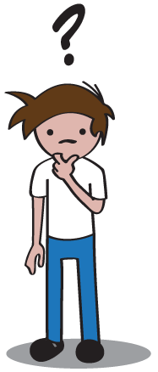
Question
What will happen to our water supply if the environment is polluted?

Research
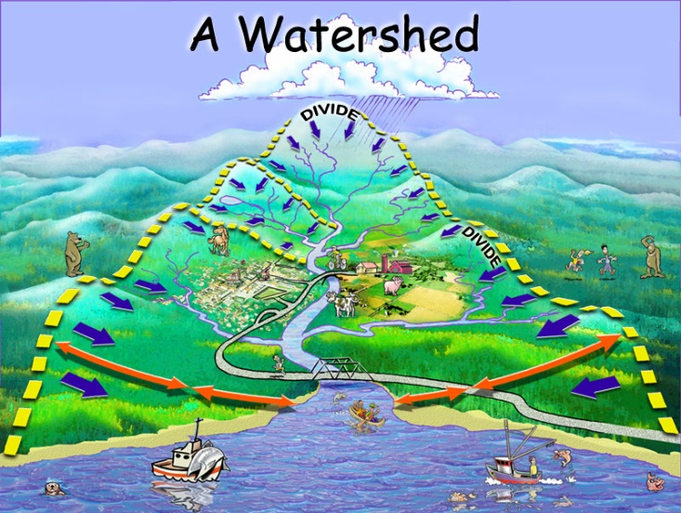
During a rainstorm, the water that flows over the land is called runoff. The runoff collects in streams and small
rivers, called tributaries. Runoff flows through the tributaries into larger rivers and eventually collects in a large body of water such as an ocean or lake.

The area of land where all of the lake or ocean water comes from is called a watershed. If you look at a watershed from the sky, it looks like the twigs and branches of a tree. All of the watersheds on earth are separated by high land, like ridges or mountains. These separations are called divides.

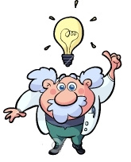
Hypothesis
(Make your best guess at the answer to the question at the top of the page.)

If we pollute our environment, I think the water supply will _______________________
________________________________________________________________________

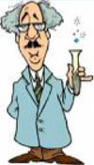
Experiment

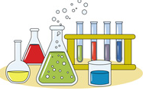
Materials
- Sheet of white paper
- Shallow pan
- Colored markers
- Spray bottle of water

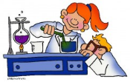
Procedure
- Crumple the sheet of paper and then smooth it out. Make sure you leave some ridges on the paper.

- Using markers, color along the creases in the paper with different colors. (These will represent pollutants in the watershed, such as fertilizer, pesticides, and litter.)

- Lay the sheet of paper in the pan and shape it so it looks like a watershed.

- Spray the paper with water.

Observations
Draw a pictures of what your watershed model looked like before and after you made it rain.
Before After

Analysis
(Answer the following questions about your experiment.)

1. What happened to the pollutants that were in your watershed environment?
________________________________________________________________________
________________________________________________________________________

2. How did the pollutants affect the water in this watershed?
________________________________________________________________________
________________________________________________________________________

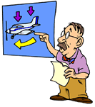
Conclusion
(Using what you have learned, go back and answer our original question.)

If we pollute our environment, I the water supply will ____________________________
________________________________________________________________________

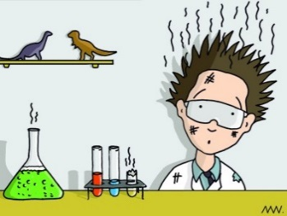
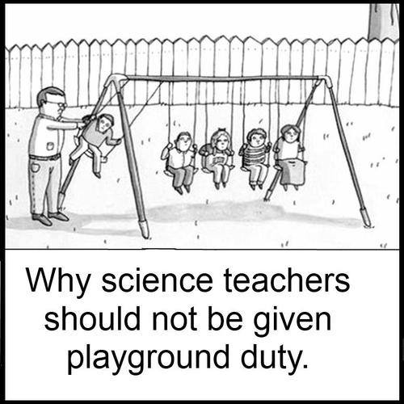

Pollution in the Water - Lab Prep

Georgia Performance Standards – Science
Content
S3L2. Students will recognize the effects of pollution and humans on the environment.
a. Explain the effects of pollution (such as littering) to the habitats of plants and animals.

Scientific Process
S3CS1. Students will be aware of the importance of curiosity, honesty, openness, and skepticism in science and will exhibit these traits in their own efforts to understand how the world works.
a. Keep records of investigations and observations and do not alter the records later.
S3CS4. Students will use ideas of system, model, change, and scale in exploring scientific and technological matters.
a. Observe and describe how parts influence one another in things with many parts.
b. Use geometric figures, number sequences, graphs, diagrams, sketches, number lines, maps, and stories to represent corresponding features of objects, events, and processes in the real world.
S3CS5. Students will communicate scientific ideas and activities clearly.
b. Make sketches to aid in explaining scientific procedures or ideas.
S3CS8. Students will understand important features of the process of scientific inquiry.
a. Scientific investigations may take many different forms, including observing what things are like or what is happening.

Materials Set-Up
Student Stations
All student stations will need:
- Sheet of white paper
- Shallow pan
- Colored markers
- Spray bottle filled with water

Teaching Notes
Common Misconceptions
The hardest thing for the kids to understand in this lab is how their experiment transfers to the real world. While students are modeling the watershed, be sure to relate each part to the real world (paper is the land, creases are the hills, ridges, and mountains on the land, markers represent pollution).

Questioning Students:
While students are working, introduce them to different types of pollutants that may be found on the ground (pesticides, fertilizer, litter, etc.)

Sample questions you could use:
What kind of pollution might be on the land? How did it get there?
How does pollution affect the land?
How can we prevent pollution in a watershed?

